# **Tasks**

**Learners have to develop a dashboard to support the answers to the following questions and suggestions for places for newer restaurants.**

**Objective Questions**:

1. What is the total no. of tables present in the data?

**Answer**. 2 tables are presents in given datasets, 1 table in ‘Raw Data’ sheet and 1 table in ‘Country description’ sheet.

**______________________________________________________________________________________**

1. What is the total no. of attributes present in the data?

**Answer**. In ‘Raw Data’ Sheet- 24 attributes are available, and in ‘country description’ sheet- 2 attributes

**_______________________________________________________________________________________**

1. How many categorical columns are there in the data? [Search about categorical and continuous data, and try to answer this question]

**Answer**. 15 **Categorical column** are available – Restaurant ID, Restaurant Name, Country Code, Country Name City, Locality, LocalityVerbose, Cuisines, Currency, Currency Abbreviation, Has_Table_booking, Has_Online_delivery, Is_delivering_now, Switch_to_order_menu, Cost with currency abbreviation (Average_Cost_for_two+ Currency abbreviation) etc.

**Continuous variables are :-** Longitude, Latitude, Price_range, Votes, Average_Cost_for_two, Average_Cost_for_two ($), Rating, Datekey_opening, Opening year

**______________________________________________________________________________________**

1. The data consists of some inconsistent and missing values so ensure that the data used for further analysis is cleaned.

**Answer**. Added “American” to Cuisines Column for missing values because missing values was there for USA country only. And also added year column to find no. of restaurants opened each year using =YEAR(W844) function.

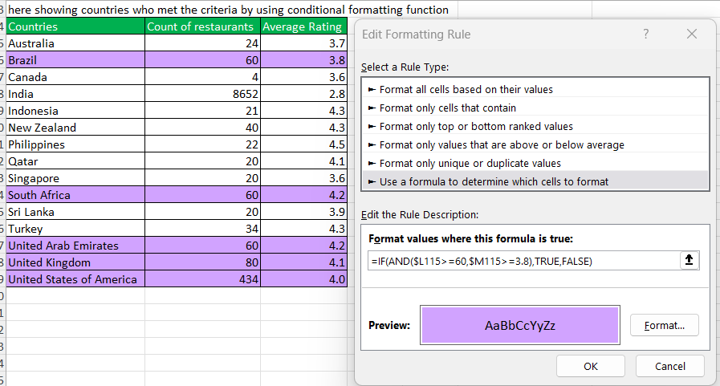The ‘=year(cell_refrence) this function extract year from ‘Datekey_Opening’ column and it will dynamically applied raw by raw.

**______________________________________________________________________________________**

1. Using the Look Up functions, fill up the countries in the original data using the country code.

**Answer**. =yes it’s done and the formula which is used that is :-

=VLOOKUP(C2,’CONTRY DESCRIPTION’!$A$1:$B16$,2,0)

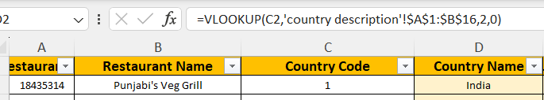

**_______________________________________________________________________________________**

1. Create a table to represent the number of restaurants opened in each country.

**Answer**. Answer is given in the pivot table in cell A7 given in sheet ‘**objective’.**

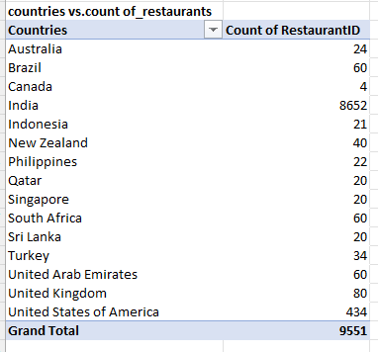

**__________________________________________________________________________________________**

1. Also, the management wants to look at the number of restaurants opened each year, so provide them with something here.

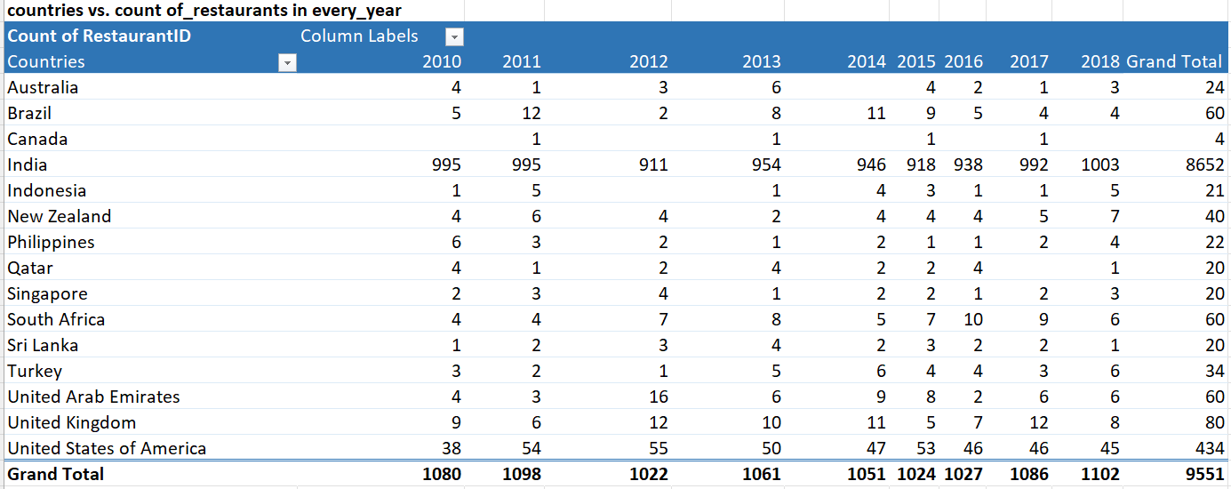**Answer**. Yes, here provided count of restaurants of each country in every year. The pivot table given in cell A31 in sheet ‘**objective’.** This pivot table shows question 6 and 7 together.

**_________________________________________________________________________________**

1. What is the total number of restaurants in India in the price range of 4?

**Answer**. 388 restaurants are available in India in the price range of 4. Pivot table given in cell A57 in excel sheet ‘**objective’.** To achieve this, created a pivot table in which countries name in raw, price range in column, and in values kept count of restaurants and also created a slicer of price range so can filter out price range 4 from it.

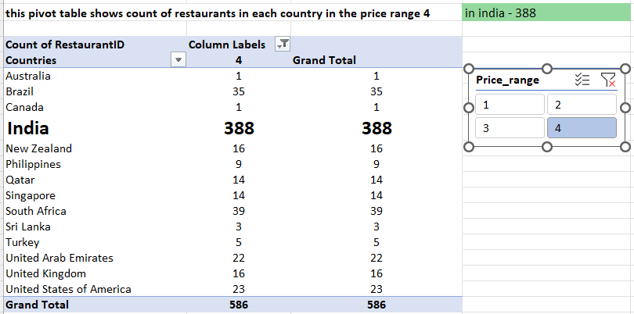

**_________________________________________________________________________________**

1. What is the average number of voters for the restaurants in each country according to the data?

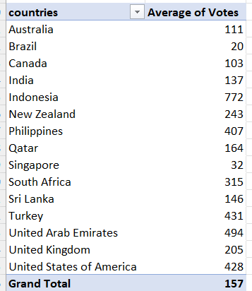**Answer**. Showing average number of voters for the restaurants in each country. Pivot table is given cell A80 in excel sheet ‘**objective’**.

**_________________________________________________________________________________**

1. Calculate the average rating for all the restaurants that have price_range < 4 and provide online delivery. Use only the “IF” function, Logical Operators, and Aggregation functions to solve this problem. **[Note: Don’t use Conditional aggregation in this question.]**

**Answer.** To achieve this applied formula :-{ =ROUNDUP(AVERAGEIFS('Raw Data'!X2:X9552,'Raw Data'!S2:S9552,"<4",'Raw Data'!P2:P9552,"yes"),4) } = 3.2739. also shows in cell B104 in excel sheet **‘objective’.**

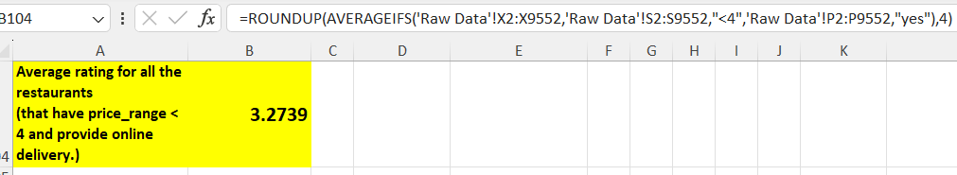

**__________________________________________________________________________________________**

1. Using Conditional formatting highlight the rows of restaurants that are located in the countries or cities that you’ve suggested to the management for opening new restaurants.

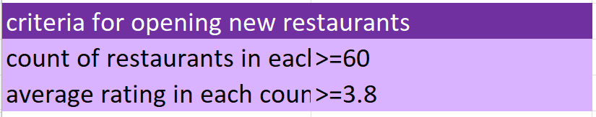 **Answer**. As per the given data to open new restaurants we can select countries on the basis of following criteria this is given in excel sheet in ‘**objective’ in A133**:-

These criteria selected because where restaurants are growing in number and their ratings are increasing, it is only because their customers' demands are increasing, suggested countries and restaurants are shown in sheet **“Raw Data”**  by using conditional formatting function and also created a table and chart of suggested countries as per the criteria in sheet objective in cell A137.

* To achieve this created a table in “**country description**” sheet which shows count of restaurants in each country and average rating of each country.
* After this inserted 3 columns :-
  + “**Total restaurants in each country**”(‘E’)- shows count of restaurants in each country.
  + **“Rating of countries” (‘Y’)-** shows average rating of each country.
  + **“Suggested countries”(‘AB’)-** shows suggested countries which are eligible for open new restaurants as “TRUE” and “FALSE”.
* After applied formula the suggested countries are listed as “**TRUE**” values in this column, and rest are showing as “**FALSE**”.
* The formula is **=IF(AND(E2>=60,Y2>=3.8),TRUE,FALSE)**
* After this wrote “**TRUE**” in cell **AD2** which is using in conditional formatting.
* Used conditional formatting function to highlight restaurants.
* Formula applied in conditional formatting: -

=$AB2=$AD$2

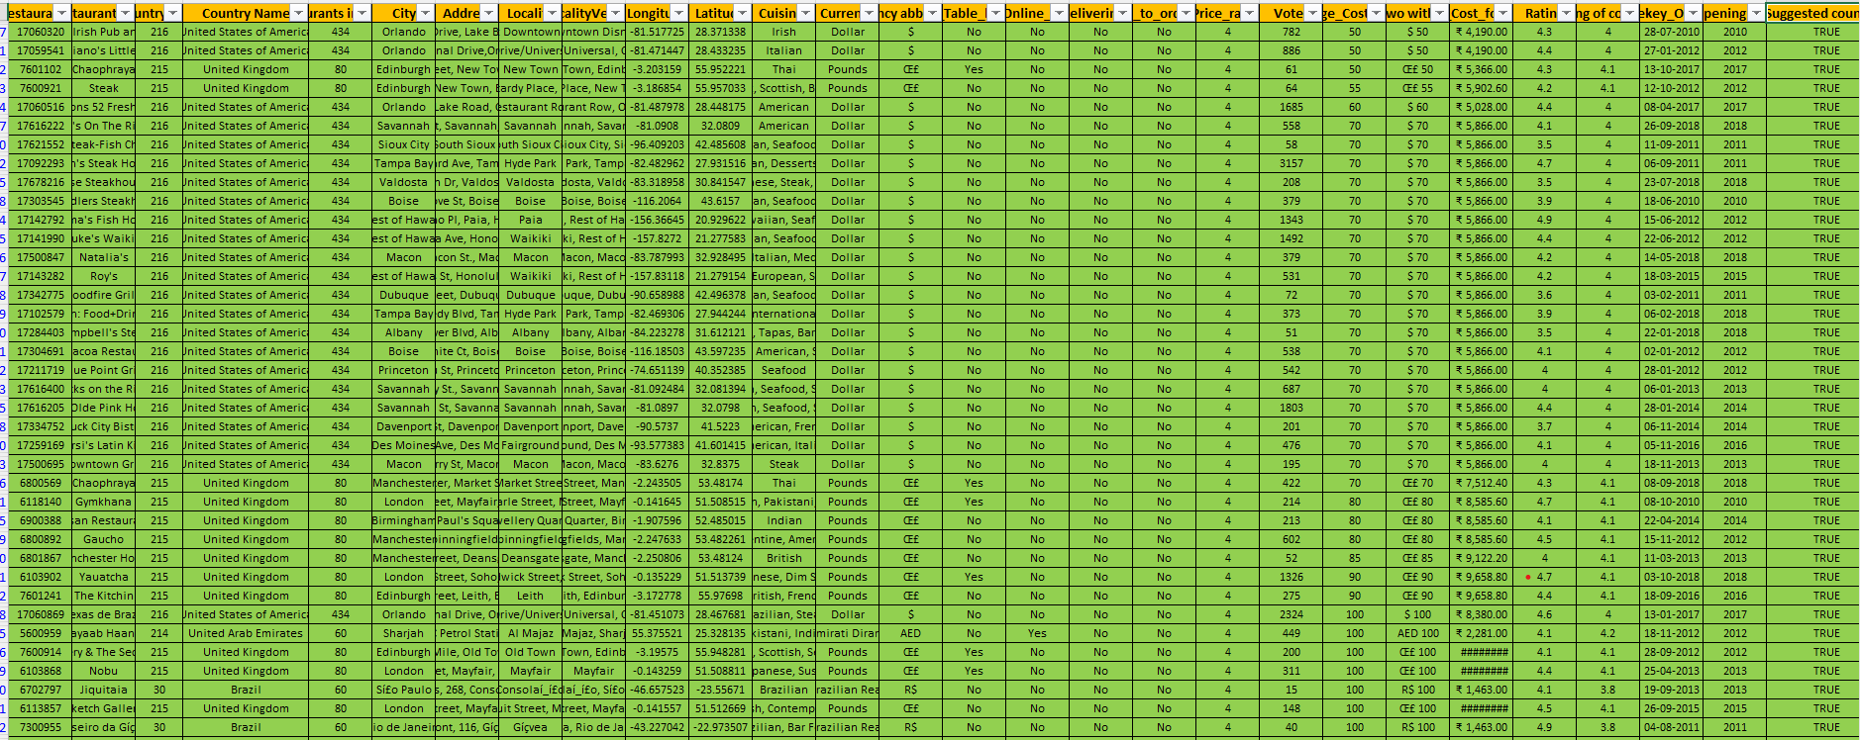

**__________________________________________________________________________________________**

1. Create a new customized price column that consists of the abbreviation/symbol of the currency along with the Average_cost_for_two value. [Use string operations to do this task]

**Answer**. Done; =CONCATENATE(M2," ",T2)

To reach this goal, the following steps were executed:

* Inserted one more column on the right of the Currency column.
* Applied the **text-to-columns** function to extract the abbreviation and currency, with **‘(‘** delimiter as the dividing character.
* After this, the currency and its abbreviation were separated in two different columns.
* The extracted abbreviation included an unwanted “**)**”, for example **'Rs.)'**, which was eliminated by replacing it with a blank.
* After this to the right of the “**Average_cost_for_two**” column, a new column was inserted.
* To link the currency abbreviation with the “**Average_cost_for_two**” column values, the Concatenate function was used in the new column.
* "This new column was labelled as “**Cost with currency abbreviation**”.

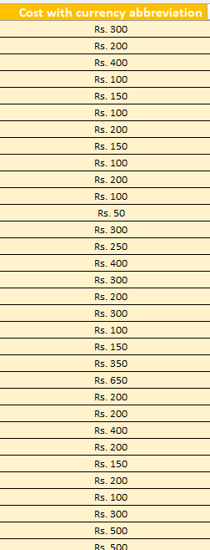

1. How can you create an array formula in Excel or Google Sheets to count the number of restaurants listed that do not offer online delivery, are in the lowest price range, and have an average cost for two people less than or equal to 250 Indian Rupees?

**Answer**. Here ‘**’Raw Data’!O2:O9552=”No”**’ is shows online delivery column

‘**’Raw Data’!R2:R9552<=1**’ is shows Price range column, that is <= 1 which is lowest price range

‘**’Raw Data’!w2:w9552<=250**’ is shows customized column which consist **all average cost for two in rs. Indian currency**. This is given in excel sheet **‘objective’ in cell B171**

Formula is : - **{=SUM(('Raw Data'!O2:O9552="No")*('Raw Data'!R2:R9552<=1)*('Raw Data'!W2:W9552<=250)) }**

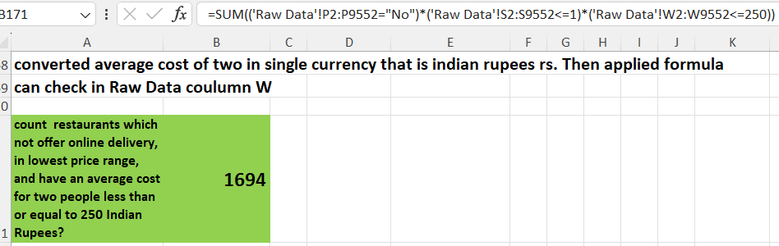

**__________________________________________________________________________________________________________________________________________________________________**

**Subjective Question:**

1. Suggest a few countries where the team can open newer restaurants with lesser competition. Which visualization/technique will you use here to justify the suggestions?

**Answer**. Can refer this answer from sheet **‘subjective’ in cell A5 and D5, where charts are also given.**

The data analysis indicates that we can create new restaurants in nations where we are receiving favourable feedback from customers, and restaurants are growing in numbers based on ratings.

We can examine the average rating of each country and the number of restaurants in each country to examine consumer feedback.

we should focus on those countries where customer demands are high.

To determine this total number of restaurants, it will be useful because it's obvious that where restaurants are growing in number, it is only because their customers' demands are increasing.

As per my analysation **Brazil, United Arab Emirates, United Kingdom, United states of America,**

**and South Africa** are the countries where we should open the new restaurants. On the basis of count of restaurants (countries where count of restaurants>=60), average rating (countries where average rating >=3.8) showing this table in excel -sheet name :– ‘**subjective’**

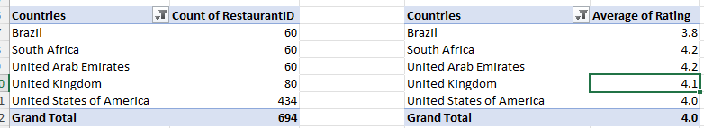

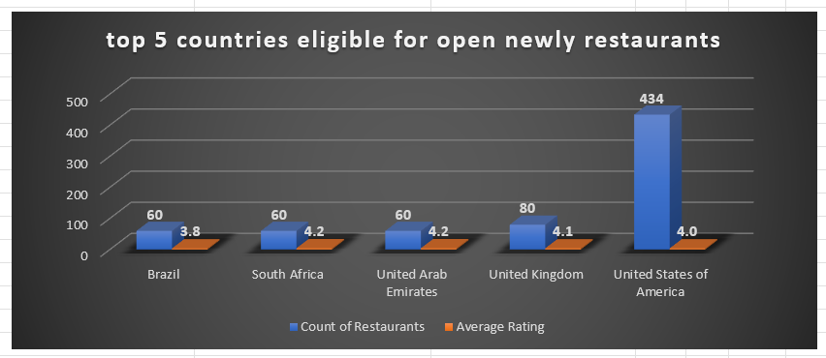

To show only eligible countries as per the criteria created a different table and applied filter according to criteria finally got results and shows in chart for better analysing.

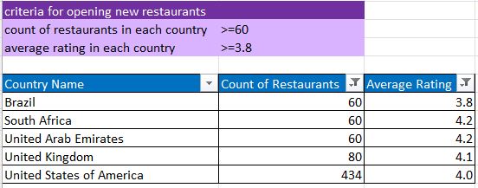

**__________________________________________________________________________________________**

1. Come up with the names of States and cities in the suggested countries suitable for opening

restaurants.

**Answer**. Tried show this answer in **excel cell A51 in sheet** **‘subjective’**.

We can create new restaurants in cities where we are receiving favourable feedback from customers to analyse it should consider average rating.

In cities if online delivery facility is not available so we can use this point as to earn more rating, and by add this feature we can attract more consumer toward our new restaurants and where online delivery is available, we can open more restaurants there by improving their rating and quality so we can earn more profit, hence we should add online delivery facility in our new restaurants.

* Initially, I created a pivot table to display the average rating of each city.
* Condition decided that if average rating of each city is greater than or equal to 3.1 and lesser than or equal to 4.2, so city will be eligible to open new restaurants. Below 3.1 rating will come in least rating, means not good in performance and quality and above 4.2 rating is coming in highly rating, means high competition hence 3.1 to 4.2 is justified.
* After that created a table which shows cities name of selected countries, and average rating.
* Used conditional formatting also to show in table that which cities are eligible, so that can understand easily.

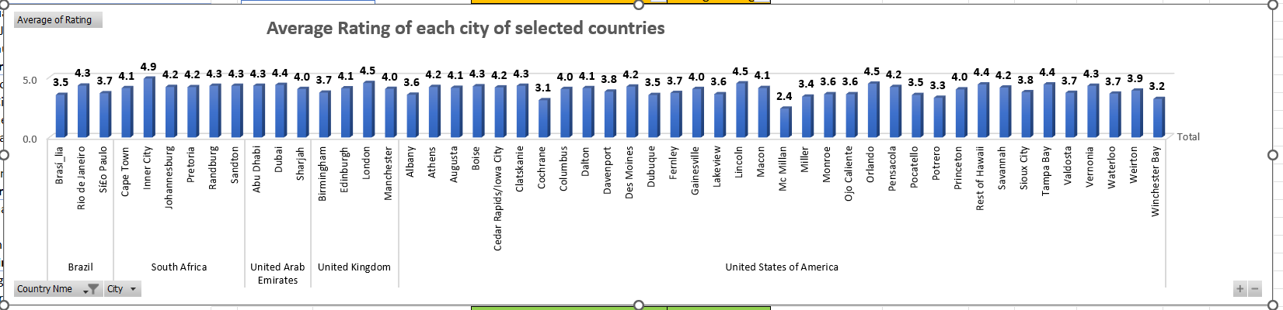

**.**

Cities are eligible to open new restaurants, that are :-

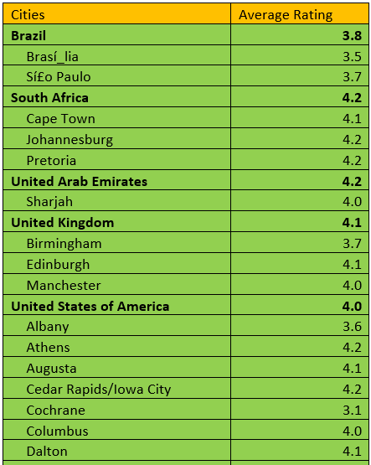

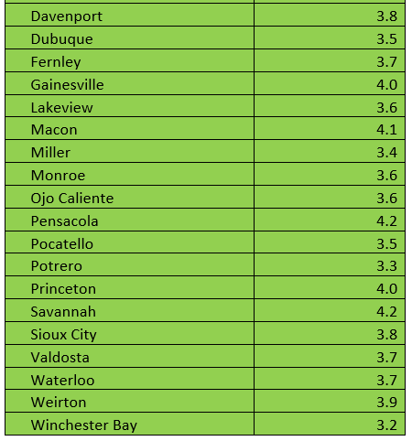

**Conclusion** - Therefore we can open new restaurants in those cities whose names are provided in above and highlighted in excel sheet **‘subjective’** those ratings are greater than or equal to 3.1 and lesser than or equal to 4.2.

**_________________________________________________________________________________**

1. According to the countries you suggested, what is the current quality regarding ratings for restaurants that are open there?

**Answer**. Rating of suggested countries,showing **this table in cell A130 in excel sheet name :–** ‘**subjective’.**

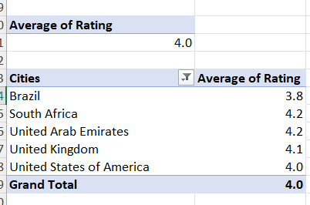

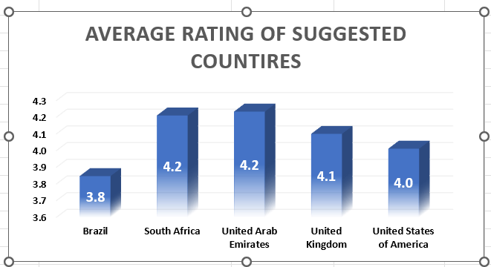

**_________________________________________________________________________________**

1. Also, what is the current expenditure on food in the suggested countries, so we can keep our financial expenditure in control?

**Answer**. **Converted average_cost_for_two in Indian currency (rs.).**

**Brazil, United Arab Emirates, United Kingdom, United states of America, and South Africa** these countries are suggested because in these countries favourable average price and where are too less average price range it means there are a huge competition.

Table is given in excel – sheet name :- **subjective, cell A149**

Based on a comprehensive analysis of average price ranges in rupees across each recommended country.

By analysing this graph, we got some important points: the United Kingdom stands tall with the highest price range of 5131, yet its average rating of 4.1 shines bright with a justified and impressive score! This winning combination begs the question - why tamper with success? Instead of slashing prices, we can supercharge growth by introducing online delivery services in newly opened restaurants, enticing more customers and boosting profits. Hence price range are suitable in every country according to their other factors.

Both graph of average rating and average of price range in Rs. (Indian rupees) of suggested countries are given below :-

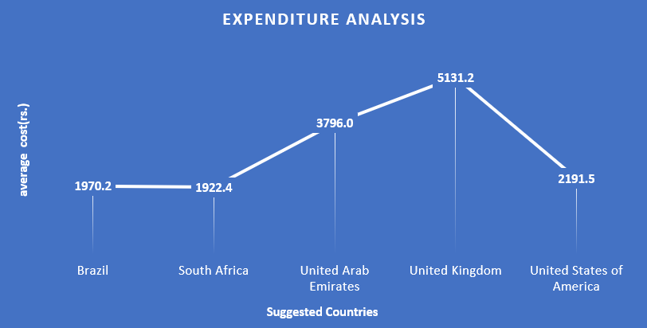

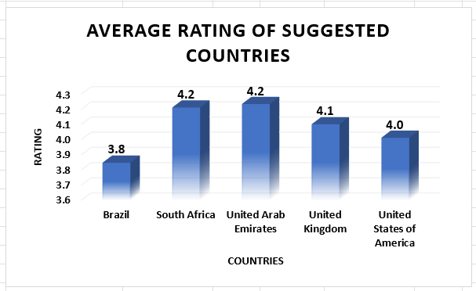

**__________________________________________________________________________________________**

1. Come up with the names of restaurants from the recommended states that are our biggest competitors and also those that are rated in the lower brackets, i.e. 1-2 or 2-3.

**Answer**. Can refer this answer from **excel sheet ‘subjective’ in cell A198**

Criteria -

The biggest competitor’s in following cities which has high ratings in between 4.3-4.9

The Biggest Competitor’s average ratings lie in range (4.3 - 4.9) :-

**Brazil**

**­­­­­­­­­­­­­­________________________________________________________________**

* + - * Rio de Janeiro

**South** **Africa**

**________________________________________________________________**

* Inner City
* Randburg
* Sandton

**United Arab Emirates**

**________________________________________________________________**

* + - * Abu Dhabi
      * Dubai

**United Kingdom**

**________________________________________________________________**

* London

**United state of America**

**________________________________________________________________**

* Boise
* Clatskanie
* Lincoln
* Orlando
* Rest of Hawaii
* Tampa Bay
* Vernonia

Suggestion- new restaurants need to provider food with highly quality, they need to provide extra facility such as online delivery and table booking to attract more consumers.

Lower Bracket Restaurants with rating (1-2 ) :-

in lower brackets rating ranges between 1-2 no Cities lies

Lower Bracket Restaurants with rating (2-3) :-

To get a city name that comes with a lower rating between 2-3, you can apply the filter in **'Table 1**' and then will get.

This shows in excel sheet ‘**subjective’ cell A264**

|  |  |
| --- | --- |
| cities | Average Rating |
| Mc Millan | 2.4 |

After filtered out in ‘**'Table 1’** in average Rating between 2-3, will get only 1 city that is

**Mc Millan.**

Suggestion – here new restaurants need to analysis all the factor who has much high rating and need to improvement in their services, basically need to understand customer’s requirement as per their interest.

**__________________________________________________________________________________________**

1. Which cuisines should we focus on in the newer restaurants to get better feedback? Does the choice of cuisines affect the restaurant ratings?

**Answer**. Can refer this ans. From excel sheet name ‘**subjective**’, **cell A277**

Cuisine connoisseurs, take note! Our analysis reveals that the type of cuisine has a surprisingly minimal impact on ratings. But, to give you a flavor of what works, here's a list of cuisines and their average ratings in our suggested countries. Take a cue from the locals and serve up the most popular cuisines in each location to delight your customers:-

Brazil

_________________________________________________________________________________

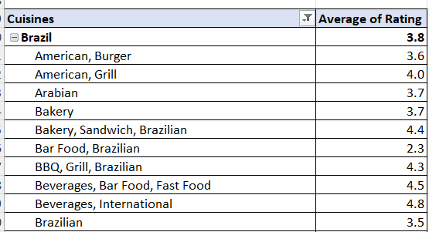

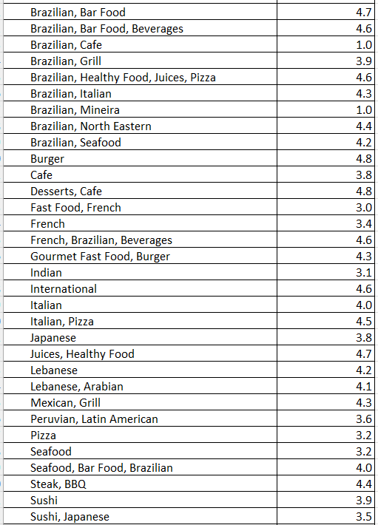

South Africa

_________________________________________________________________________________

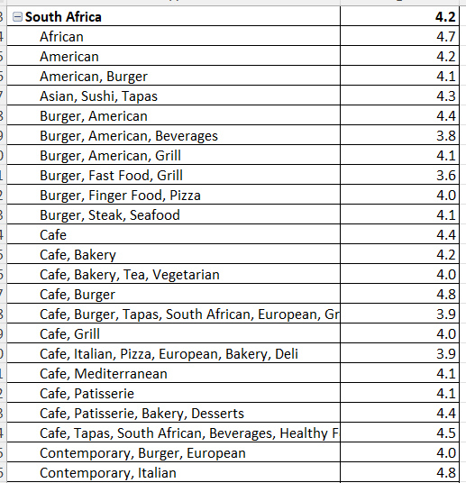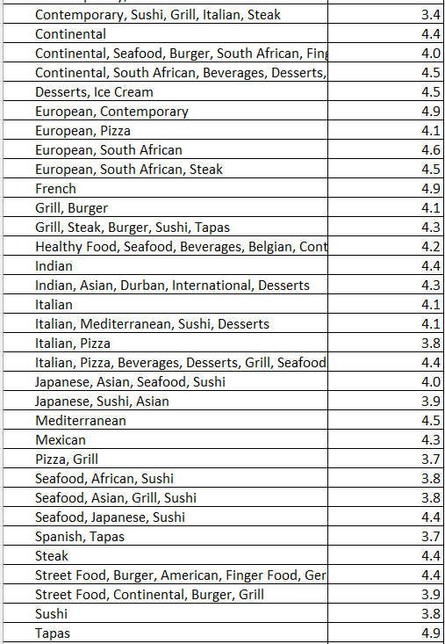

United Arab Emirates

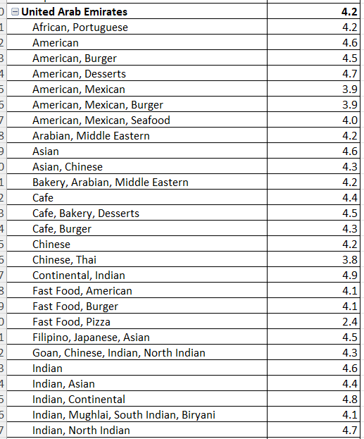______________________________________________________________________________________

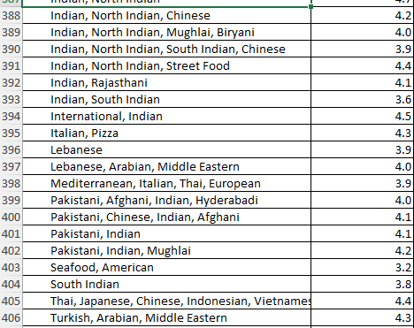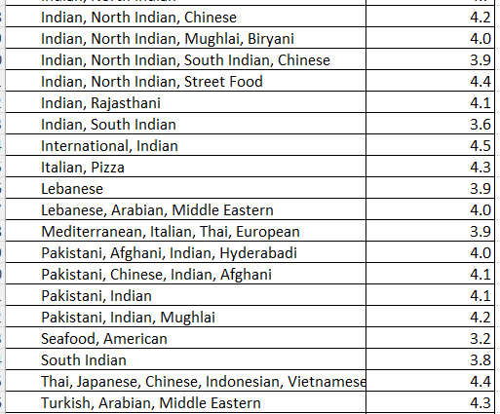United Kingdom

_________________________________________________________________________________________

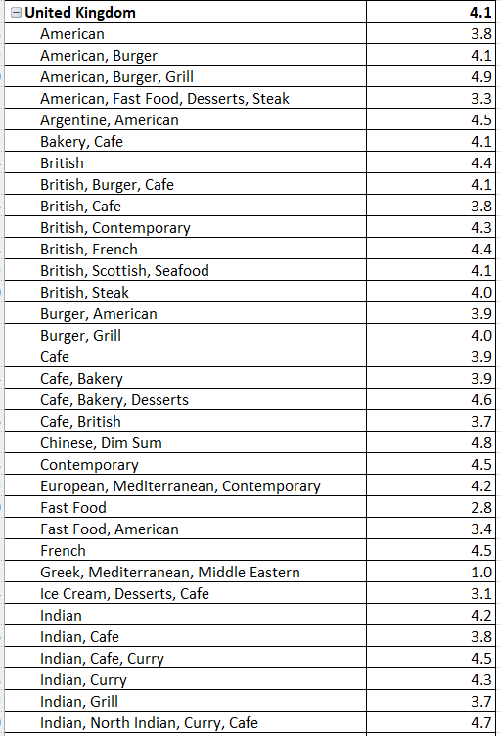

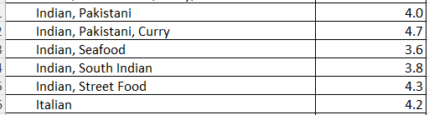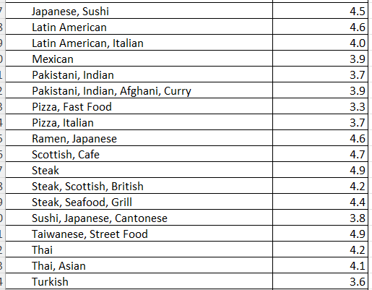

United State of America

_________________________________________________________________________________________

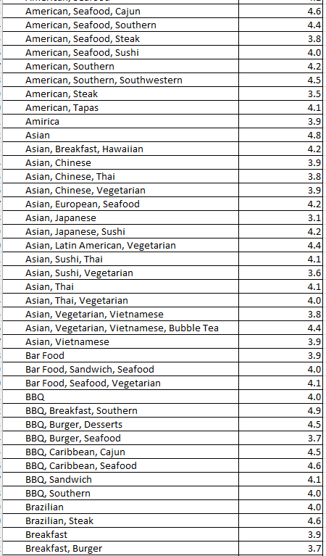

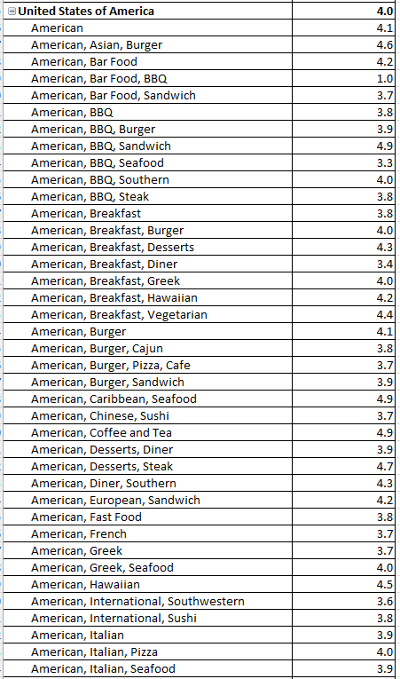

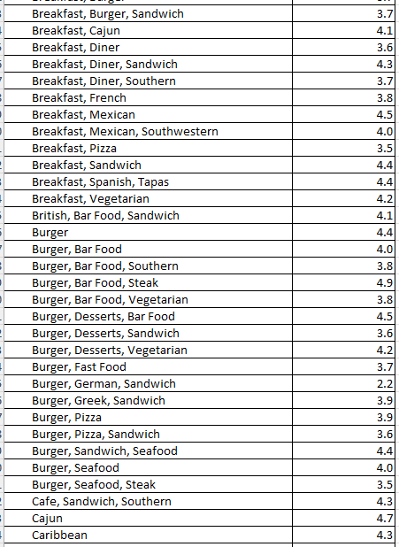

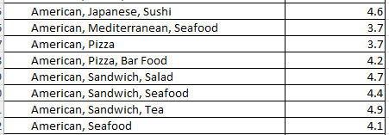

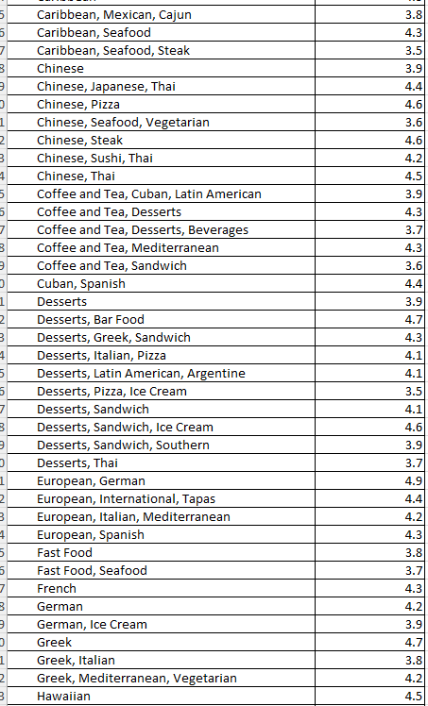To be continue…….

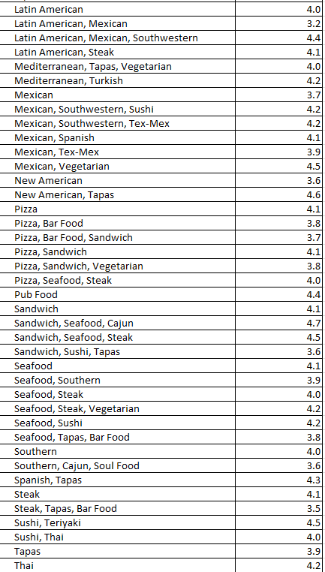

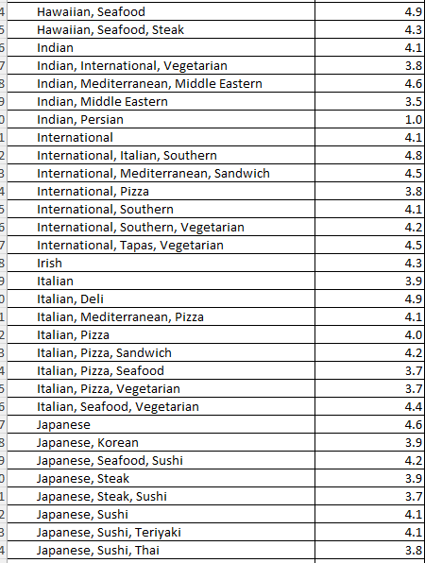

By offering the most beloved cuisines in each country, new restaurants can dish up a recipe for success and leave a lasting taste in the minds of their patrons.

We can select those cuisines for newly open restaurants which are very common in their country, as we know that cuisines are not much significant on ratings.

**_______________________________________________________________________________**

1. According to our current data, should we go for online delivery and table booking? Does that affect the customer’s ratings?

**Answer**. Yes, we should go for online delivery and table booking. Table is given in excel – sheet name :- **subjective , in cell E732.**

For better understanding, I created a pivot table that shows the rating vs. whether online delivery is available or not, we can see here that the rating is 2.75 in those countries where the online delivery facility is not available, whereas 3.29 rating can see where online delivery is available, which is higher than 2.75 rating. Hence it proved that we are getting more profits and positive feedback from customers regarding online delivery, therefore we should provide an online delivery facility in our new restaurants.

Table is given in cell E714 in excel sheet subjective.

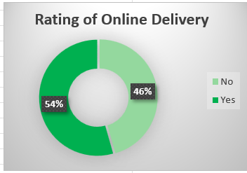

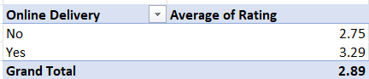

same as we can see for table booking also, created a pivot table that shows the rating vs. whether Table booking is available or not, **can refer this table from excel sheet ‘subjective’ in cell A732**

we can see here that the rating is 2.81 in those countries where the table booking facility is not available, whereas 3.48 rating can see where table booking is available, which is higher than 2.81 rating. Hence it proved that we should provide the table booking facility in our new restaurants.

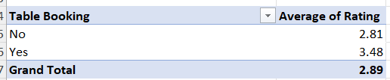

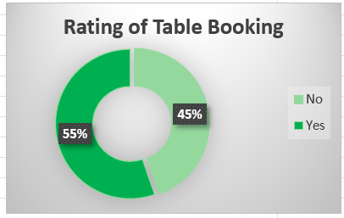

**Hence, it’s proved that we should go for online delivery**

**And Table booking.**

**__________________________________________________________________________________________**

1. Should the team keep the rate of cuisines higher? Will that affect the feedback? According to our data are the rates of cuisines and ratings, correlated?

**Answer**. **Can refer this answer from excel sheet ‘subjective’ in cell A759,** To solve this question followed these steps –

* created a pivot table in which average cost per to two taken and in value average rating available for all price of cuisines.
* After that create a normal table and inserted a line chart,
* Through this chart can see that average rating and rate of cuisines are not depends on each other. That means rates of cuisines and ratings are not correlated.
* So, it’s proved that after increase rate of cuisines will give better profits and feedback from consumer side, it’s not confirmed it might be give loss also. So instead of increase rate of cuisines should be focus on rest factors as like online delivery, no. of restaurants, table booking etc.

Pivot table is given in excel sheet ‘subjective’ in cell A759

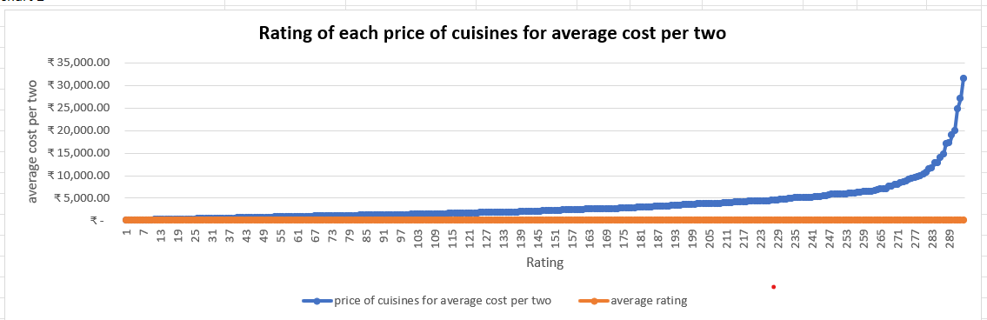

**__________________________________________________________________________________________**

1. What is the distribution of the number of restaurants of different price ranges in all the countries?

**Answer**. here is given table which shows number of restaurants of different price ranges in all the countries.

table is given in excel – sheet name – ‘**subjective’ in cell A1067.**

This chart shows that count of restaurants in different price range in country. Here can see that highest no. of restaurants comes in 1 price range in India that 4295.

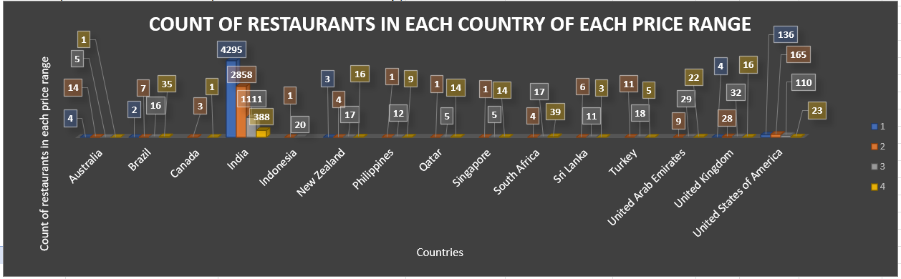

This pie chart shows that count of restaurants in each price range in percentage. In this can see that highest no. of restaurants comes in 1 price range that is 46% and lowest in 4 that is only 6%.

**Can refer this chart from pivot table which is given in excel sheet ‘subjective’ in cell A1091.**

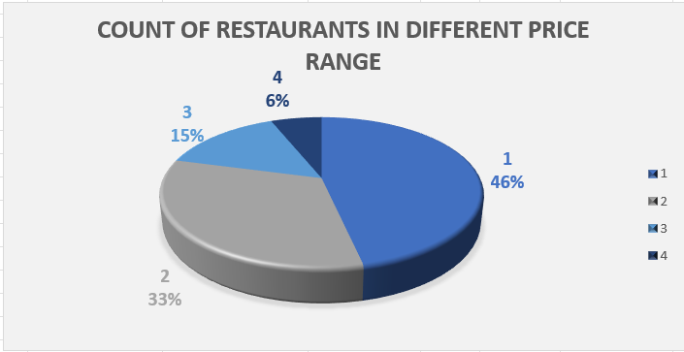

**__________________________________________________________________________________________**

**__________________________________________________________________________________________**

1. Explain your approach in brief for suggesting countries/cities in order to open new restaurants, if the objective and subjective questions would have not been given to assist you. **[you have to give bullet pointers in order to answer this question]**

**Answer**. If in case objective and subjective question are not helping then also, I may adopt the same methodology to find out suitable location to open newly restaurants in countries/cities.

I added some kind of things which helped me to more clear and more understandable which are :-

* I added Currency exchange rate info. In (rs.) in country description column.
* I created a table in “**country description**” sheet which is showing count of restaurants and average rating of each country.
* I inserted three new columns in “Raw Data” sheet
  + “**Total restaurants in each country**”- shows count of restaurants in each country.
  + **“Rating of countries” -** shows average rating of each country.
  + **“Suggested countries”-** shows suggested countries which are eligible for open new restaurants as “TRUE” and “FALSE”.
* I used conditional formatting function in **Raw Data** sheet with the help of ‘**Suggested countries’** column.
* I used conditional formatting function in subjective question 2 also so that can easily highlight those cities which are more suitable to open new restaurants.
* I created both pivot table and normal table In subjective question 8th to make better understand that rate of cuisines and it’s rating are not correlated, also inserted charts for both tables.
* Some charts and pivot tables are given in excel sheet ‘analysis charts’ where I tried to show some important pivot tables like:- such as average votes of suggested countries **table given in cell B5**, average votes per price range **table given in cell B24,** average rating of all countries **table given in B43**, total restaurants who provides online delivery **table given in cell N6**, total restaurants who provides table booking facility **table given in cell N25.**
* One more chart inserted in sheet “dashboard charts”, this chart shows only those cities has highest rating between 4.5 – 4.9 and some shortlisted for better understanding.

Therefore, these some important things are not given in objective and subjective questions.

**The dashboard must consist of Year-wise and country slicers.**